Mum’s Lounge Article FINAL:

Twenty Minutes to Rock Stardom!
Mum’s Lounge INTRO: Mama Mia… This Dancing Queen was just Born This Way! I’ve always loved music and still dream of being a rock star beyond the walls of my shower screen. So, you can imagine that I was literally Thunderstruck when I read about Rock Star For A Day. If you’re a mum and you’ve always wanted to run your own business or earn additional income but Don't Want To Miss A Thing, Rumour Has It that with Rock Star For A Day children’s party entertainment franchises, you can be Takin' Care Of Business right from your own home and in your own time.
We have all spent time on Sunday nights watching our favourite talent show waiting to see what songs our favourite singer will rock out for us. Don’t deny it. And don’t we all secretly think our child could do better, than the ones presenting on screen? With Rock Star For a Day, parents get to see their kids be that star ….and loving every minute of it! Rock Star for a Day parties are so much fun for the kids AND Mums! The host is focussed on spoiling the birthday child with the coolest party ever and of course, Mum gets all the kudos for throwing the best party ever! Click here to see all party details.
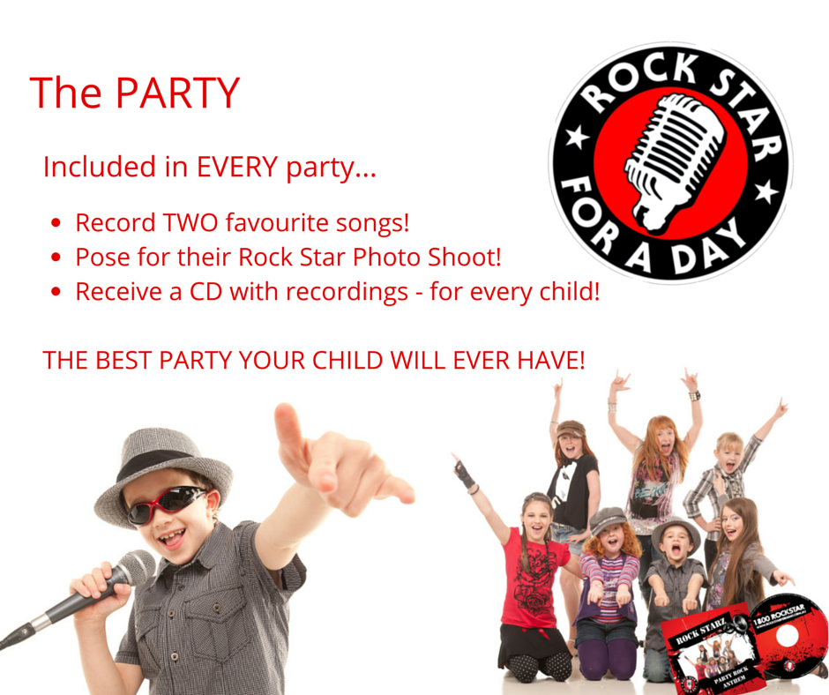
** ADD THIS LINK TO IMAGE: http://tinyurl.com/lrj5wcq
If you started your own work from home business you'd probably prefer to keep your weekends free for family stuff, right? With Rock Star for A Day you don’t have to work weekends or leave the house at night either. But do you have 2-3 hours spare each week? Do you consider yourself bubbly? Upbeat? Love music? Do you love networking and socialising? It sounds like Rock Star For A Day is for you - just add your personality!
What you need to know about Rock Star for A Day franchises:
- It’s absolutely perfect for mums
- No weekends and no nights needed!
- No technical skills required. Anyone can run it!
- Bookings managed centrally to take the stress and time out of the process.
- With quick sales cycles, you can really rely on a stable cash flow.
- All training is included in the package
- All equipment including laptops with specialised software, microphone, printer, camera, CD burner, trolley, 500 CDs in its own studio case is included
- You will develop your specific local area marketing plan with Rock Star For A Day experts
- Party hosts run each party so that you can concentrate on running a great business …and not work nights and weekends!
- Low upfront and ongoing fees with no property rent, wages or perishables
This is starting to look good, right? If you fancy earning $200+ guaranteed per party and knowing that 10 children will be having the best party fun they have ever had, then you should seriously check out here how it all works. The founder of Rock Star for A Day has made it really easy to understand the business opportunity and all your immediate questions are answered in his video. It will be the best 20 minutes you’ve ever spent!
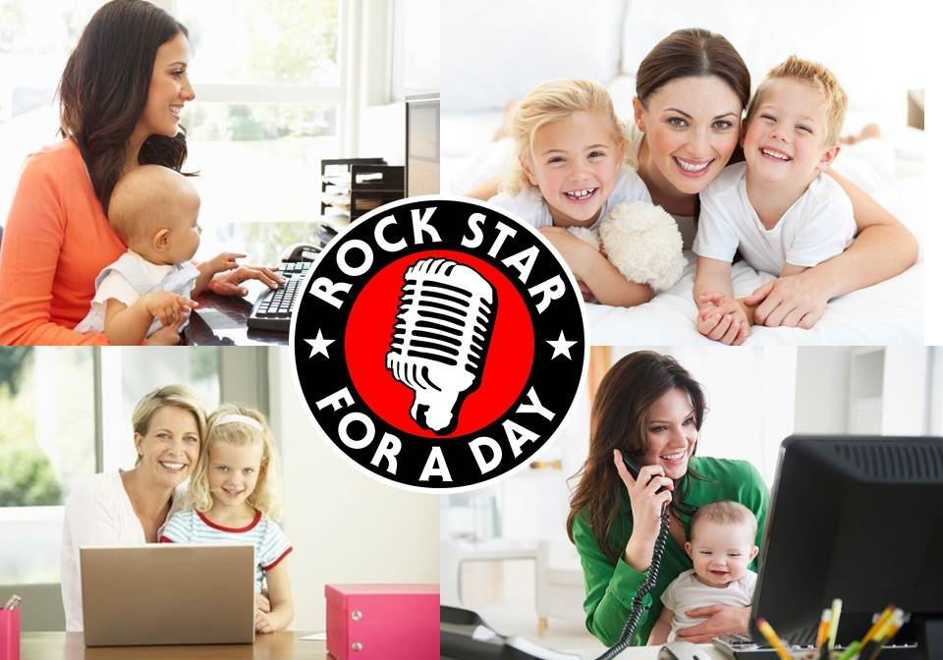
- Caption: Rock Star For A Day Franchises are perfect for mums
**ADD THIS LINK TO IMAGE: http://tinyurl.com/lrj5wcq

Why Mums?
Why not? Mums are natural leaders, organised, skilled and love to make kids happy. When you become a mum, you don’t stop dreaming or wanting to use your skills and personality. With this work from home business, you will absolutely continue to grow personally and professionally. You’ll use your organisational skills, your problem solving skills and creativity to expand your business and potentially develop new concepts for the business.
And, because everything you need is provided and you will be working from your home, the profit margins are high. Rock Star For A Day parties are so easy to sell. In fact, it is so easy, even if you aren’t a salesy person, the concept sells itself. Once parents hear about these parties word will spread fast and every child in school, sporting club and dance class will want to have one.
Getting involved in a franchise is much easier than starting your own business from scratch. No mucking around with designing websites and marketing material, registering trademarks and going through all the legal and accounting work. That's been done for you. There’s lots of franchise opportunities around but this one is definitely worth looking into.
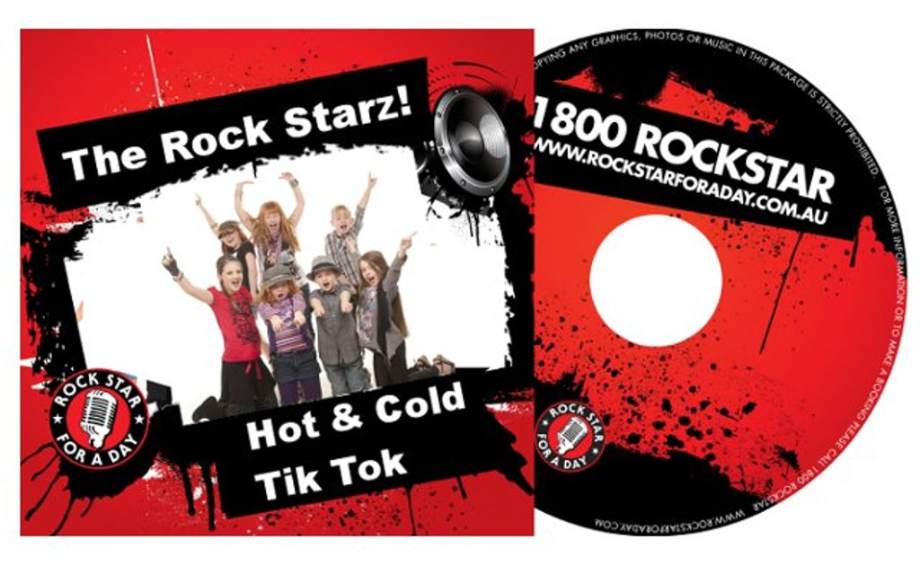
Caption: Every child in YOUR neighbourhood wants to be a Rock Star!
**ADD THIS LINK TO IMAGE: http://tinyurl.com/lrj5wcq

Who Do I Market to?
The founder of Rock Star for a Day said that most people wanting to join our team ask how the 'areas' or 'territories' work... The answer is we don't have boundaries. We have a unique system developed by Rock Star for a Day, so you can run your business anywhere in Australia. You're not bound by a territory.
So, a Local Area Marketing Plan is really important and we would help you develop this so most of your bookings are nice and close. By keeping your bookings nice and close, you could have them at 10am, 12, 2, 4 and 6pm to maximize your income. Rock Star For A Day have tried different ways over the years and keeping your marketing nice and close to you is best for your bottom line. Rock Star For A Day organize everything so you could be up and running this time next month.
So, if you’ve got the Moves Like Jagger, unleash your inner Firework and find out here how you can join one of the most exciting franchises around... and all from your own home.
Who knew it would only take 20 minutes to change your life? Do it now!
R.E.S.P.E.C.T.

